Robotics and Pathfinding: Problem Solving By Searching

Instructions for use:

- Run the provided .jar file robot.jar using the terminal (or double clicking on Windows).
- Select Potential Fields on the Dialogue box
- IMPORTANT: The robot radius has been tested at 32 and therefore completeness can only be guaranteed if the “Robot Radius” text box is set to 32.
- Select the FRACTIONAL PROGRESS planner to test the practical submission code (the other options are the provided steepest descent planners, in arc and euclidean mode).
- Select other desired options including extra obstacles and start positions.
- Press the ‘Go little robot’ button to begin the simulation

Introduction:

A goal-based agent attempting to navigate a problem area in order to reach a goal must have a complete solution that avoids obstacles and can navigate out of local minima in order to guarantee that this goal is reached. There are a number of strategies which have been developed to achieve this, and the task was to emulate some of these strategies in order to create an agent capable of solving a reasonably complex task. For the purposes of this practical, the goal based agent was a virtual robot which was to:

1) Be able to navigate to the goal (the location of which is always known to the robot) in free space regardless of the robot’s initial heading and the bearing of the goal in relation to the robot’s starting position. This would be accomplished with an alternative to the steepest gradient descent method (which was provided as part of the existing code) the fractional progress method, using either Arc or linear distance measuring to calculate potential.

2) Continue to be able to navigate to the goal despite the presence of obstacles of varying degrees of difficulty, including circular, square and C-shaped obstacles of increasing severity and optionally more complex obstacles such as narrow tunnels. This was to be achieved by supplementing the previous algorithms with extra decision making capabilities, such as those described in: “POTBUG: A Mind's Eye Approach to Providing BUG-like Guarantees For Adaptive Obstacle Navigation Using Dynamic Potential Fields”.

Design

My implementation of the program uses many of the facilities provided in the original code, the top level algorithm is provided here:
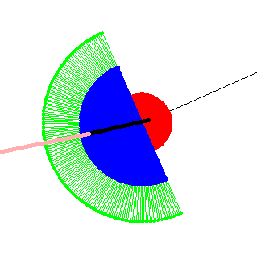The Robot; Red = Robot body, Blue = Move choices, Green = Sensor range
- The robot (red circle) ‘looks’ around itself in a semi circle and selects a number of possible ‘moves’, which are points within the semi circle (blue) formed by the centre of the robot and its radius + step size (set at 10 pixels), 90º to the left and right of the current bearing of the robot.

- For each potential move, the robot stores a ‘move score’ value (see move evaluation, below), based on the attractiveness of the move to the robot.

- If the robot is not in ‘Bug Mode’ it simply selects the most attractive move and moves there. (See ‘Bug Mode’ below).

- Repeat until the robot surface makes contact with the goal.

Move Evaluation

The robot ‘rates’ moves available to it based on the following heuristics, which are dependant on the current evaluation regime selected:

Euclidean + Arc: Greedy Steepest Descent value (implemented in provided code)

Fractional Progress:
- Arc: The evaluateFP method iterates through the available moves and passes each one to FractionalProgressArcs()(FPA). FPA then calculates the moves fractional progress using the following formula:

FP = Estimated Future Cost /(Estimated Future Cost + Past Cost) |

Past Cost = Length of the First Arc (Between Current Pos and Candidate Move
Estimated Future Cost =
Length of the Second Arc (Between Candidate Move and edge of sensor range closest to goal – known future cost)
+ Length of Third Arc (Between Edge of Sensor range and goal – unknown future cost)
+ Obstacle Potential (result of a function where OP starts at 0 an increases exponentially as distance to an obstacle increases).
The Lengths of these arcs are calculated using the provided get3Arcs method
- Linear: Similar to ‘Arc’ but instead of Arc lengths, the three relevant distances (past cost + known future cost + unknown future cost) are calculated using linear euclidean distance rather than arc length.

Bug Mode

Taking inspiration from the provided POTBUG paper, where an algorithm that combines Fractional Progress move evaluation is combined with BUG-like obstacle navigation behaviour in order to navigate complex and difficult pathways. These include tunnels and concave obstacles. BUG-like techniques are necessary because these obstacles create local minima, which means that raw Fractional Progress and Steepest Gradient Descent navigation cannot overcome them.

Local Minimum:

Fractional Progress navigation techniques are vulnerable to the local minimum problem because such obstacles create areas of the problem space, that are not the goal, which have higher Fractional Progress values than any of the others around them. Therefore, once the goal based agent has entered these areas, Fractional Progress only navigation will not allow them to leave the local minimum. In this practical, this manifested as the robot being stuck in a loop:

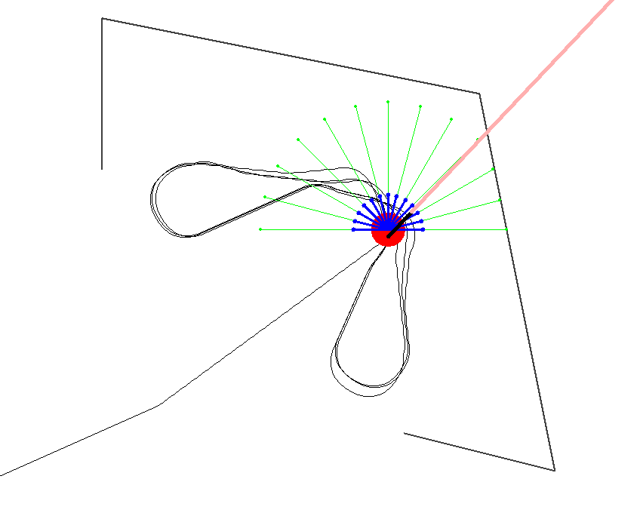
The Local Minimum Problem in Practice:

The direction of the goal is indicated by the pink line. The obstacle is the black c shaped line and the local minimum area is nicely demonstrated by the path of the robot.

The robot is unable to leave the local minimum because the Fractional progress inside the C shape is higher than that of the entrance/exit.

Therefore a technique to escape these situations is required, and the one that has been implemented is called ‘Bug Mode’: it takes a great deal of inspiration from “PotBug¹” but has been adapted to the needs of the practical.

Bug Mode is triggered when the robot approaches an obstacle at a distance close enough that the obstacle potential at the robot’s position is higher than a set threshold, which for this practical has been set at 4, which is the obstacle potential at a point ~100 pixels away from the straight edge of an obstacle. The robot then follows a new algorithm, until Bug mode is disengaged when the Robot obstacle potential falls below 4 (ie when the robot is once again in free space).
The Bug Mode Algorithm is as follows:

POTBUG A Mind's Eye Approach to Providing BUG-like Guarantees For Adaptive Obstacle Navigation Using Dynamic Potential Fields Michael Weir, Anthony Buck, Jon Lewis (2006)

